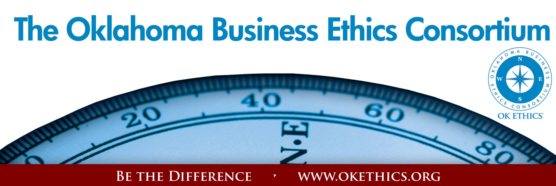
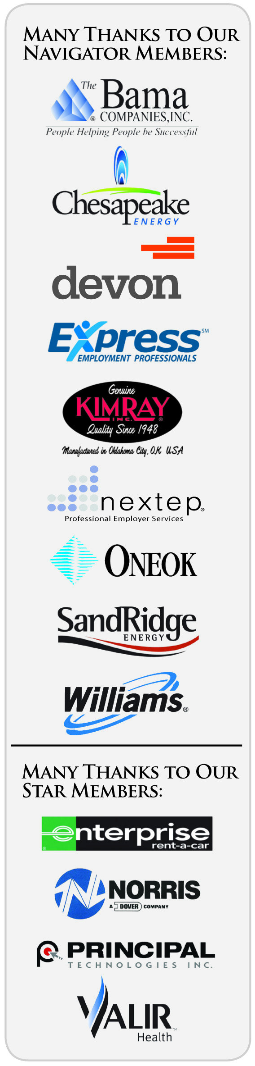
Oklahoma Business Ethics Consortium – August 27, 2009
Tulsa Chapter Meeting
Meeting Agenda

I. Welcome Nick Minden, President

II. Guiding Principle David White, Marketing Co-Chair

III. Membership Update Whitney Mathews, Membership

IV. Introduction of Panel John Stancavage, Legacy Team &
Programs Co-Chairman

V. Program John Stancavage, Tulsa World

"Staying in the Black While Going Green"

Panel Members

Cory Hoffart, Founder, Green Collar Energy
TYPros Sustainability Chair
Michael Patton, Executive Director
Metropolitan Environmental Trust
Seneca Scott, Oklahoma House of Representatives
Service Clearing Co.

VI. Q&A

Many thanks to our volunteers and Legacy team members for making this and every other meeting possible: Carol Swarthout, Lynn Flinn, John Stancavage, Micheal Oonk, Whitney Mathews, Jan Laub, Jenny Lizama, Jennifer Lyon, Tom Clatfelter, David White, Shere Rockwell, Kevin Kennemer, Kari Culp and Royce Kelly.

General Disclaimer: Members of the Oklahoma Business Ethics Consortium frequently share information concerning various issues and developments that may have legal implications. The discussions, commentary, and handouts at Consortium meetings or presentations to other organizations are for general informational purposes only. They cover only some aspects of the subject topic, and do not constitute a complete legal analysis of the topic or how it might apply to any particular set of facts. Before taking any action based on information presented during a Consortium event, participants are encouraged to consult a qualified attorney. The observations and comments of presenters at Consortium meetings and networking are the views and opinions of the presenter and do not constitute the opinion or policies of the Consortium or any of its members. Presenters are respectfully requested to avoid profanity, preaching, politics and self-promotion during their lectures.

MANY THANKS TO THESE COMPANIES WHO HAVE ALREADY RENEWED FOR FY09-10!!!

Company |  | Level |  | Chapter
Chesapeake |  | Navigator |  | Okc
Devon Energy |  | Navigator |  | Okc
Hobby Lobby |  | Navigator |  | Okc
SandRidge Energy |  | Navigator |  | Okc
Helmerich & Payne, Inc. |  | Horizon |  | Tulsa
Hertz |  | Horizon |  | Okc
Metro Technology Centers |  | Horizon |  | Okc
Enterprise Rent-A-Car |  | Stars |  | Okc
Accel Financial Staffing |  | Leading |  | Okc
Accounting Principals |  | Leading |  | Tulsa
BKD, LLP |  | Leading |  | Okc
BancFirst |  | Leading |  | Okc
Cherokee Nation Enterprises |  | Leading |  | Tulsa
Citizen Potawatomi Nation |  | Leading |  | Okc
McAfee & Taft |  | Leading |  | Okc
PricewaterhouseCoopers LLP |  | Leading |  | Tulsa
Rowland Group |  | Leading |  | Tulsa
Career Development Services |  | Trailblazer |  | Tulsa
Stanfield & O'Dell |  | Trailblazer |  | Tulsa
Coherent Contracts, LLC |  | Trailblazer |  | Moore/Norman
Leader Communications, Inc. |  | Trailblazer |  | Okc
Principal Technologies |  | Trailblazer |  | Okc
Sonic Corporation |  | Trailblazer |  | Okc
The People Group |  | Trailblazer |  | Tulsa
Walker Companies |  | Trailblazer |  | Okc
Character Training Institute |  | Frontier |  | Okc
East Central University |  | Frontier |  | Okc
Grant Thornton LLP |  | Frontier |  | Okc
Ideal Homes of Norman, LP |  | Frontier |  | Okc
Maximum Multi Media Creations |  | Frontier |  | Okc
Milam & Associates |  | Frontier |  | Tulsa
Tulsa Metro Chamber |  | Frontier |  | Tulsa
University of Tulsa |  | Frontier |  | Tulsa
Dr. Ryan Health Coach | Scout |  | Tulsa
Doellefeld Associates | Scout |  | Tulsa
Falletti Weber Consulting Group, LLC | Scout |  | Tulsa
Gilbreath's, LLC | Scout |  | Tulsa
Global Power | Scout |  | Tulsa
Greg Genua Consulting | Scout |  | Tulsa
Image Electronics, Inc. | Scout |  | Tulsa
Oklahoma Central Credit Union | Scout |  | Tulsa
RPL Management | Scout |  | Tulsa
Sales Ethics, Inc. | Scout |  | Tulsa

